**SUPPLEMENTARY MATERIAL**

**Species age cannot be obtained from phylogenies under the birth-death model**

Carlos Calderón del Cid1,2, Torsten Hauffe2, Juan D. Carrillo2, Daniele Silvestro2,3

1Laboratório de Ecologia Espacial, Instituto de Biologia, Universidade Federal da Bahia, CEP 40170-110, Salvador, Bahia, Brasil

2Department of Biology, University of Fribourg, Switzerland and Swiss Institute of Bioinformatics, Fribourg, Switzerland

3Department of Biological and Environmental Sciences and Gothenburg Global Biodiversity Centre, University of Gothenburg, Sweden

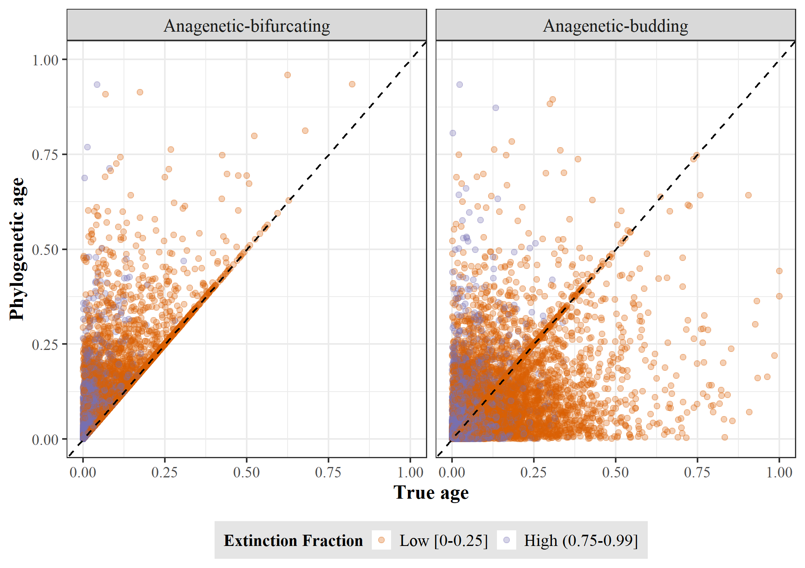

**Figure S1.** True age versus phylogenetic age at low and high extinction fraction for Anagenetic-bifurcating (left) and Anagenetic-budding (right) speciation. Each point represents a species. True and phylogenetic ages are scaled to the root age of the correspondent phylogenetic tree.

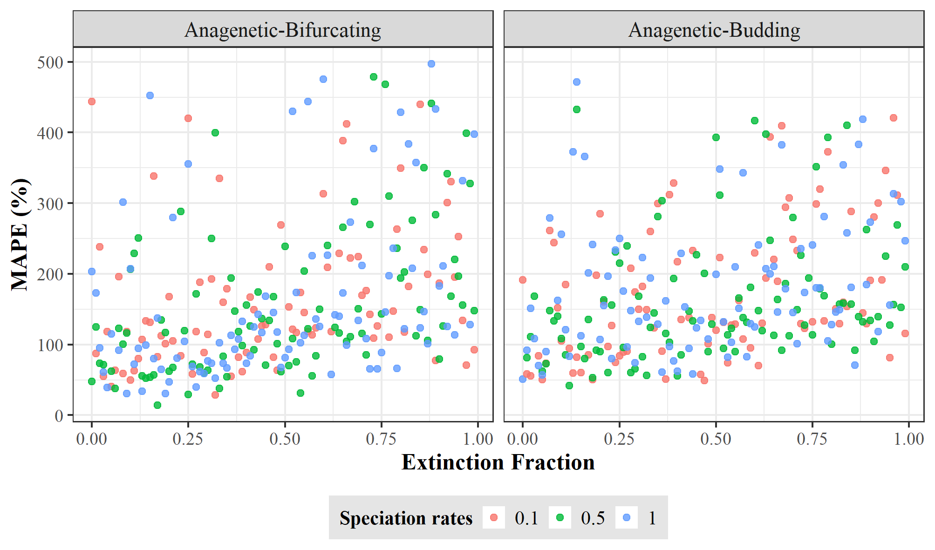

**Figure S2.** Error in equating phylogenetic age with speciation age. The error was quantified as mean absolute percentage error (MAPE) between the true and phylogenetic ages across all species for each tree simulated under Anagenetic-bifurcating (left) and Anagenetic-budding speciation (right). Each dot represents one replicate of the 300 trees for each speciation mode using different rates of speciation and extinction fraction.

*Corrective function based on the birth-death process*

We calculated the function confidence intervals’ coverage regarding the true age and, for a random tree, we plotted the relationship between the function’s mean age and confidence interval, the phylogenetic and true age.

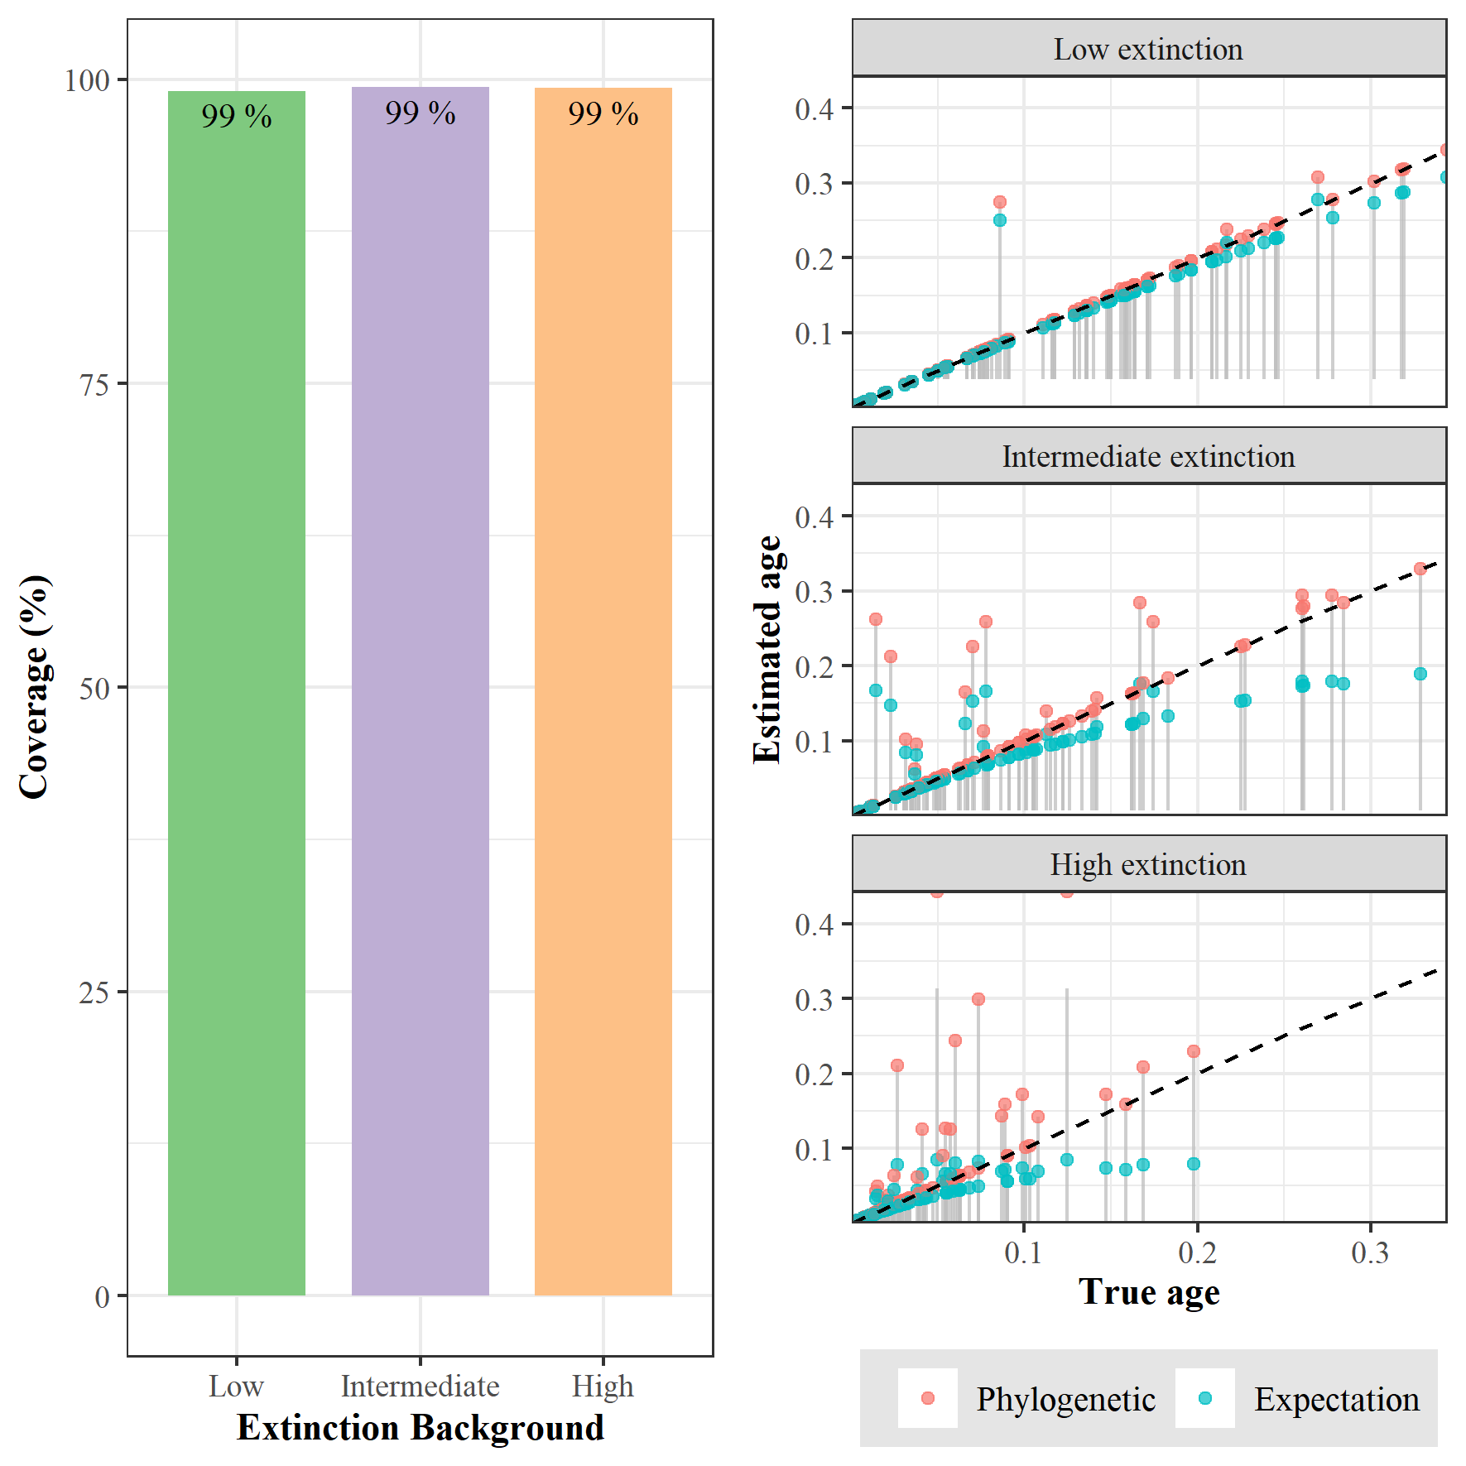

**Figure S3.** Coverage of the bifurcating function for three extinction levels. On the left, the total coverage of bifurcating function’s confidence intervals regarding the true age of 100000 species for each extinction level. On the right, the specific coverage of bifurcating function’s confidence intervals (grey lines) regarding the 100 species of one random phylogeny; red and sky-blue dots represent the phylogenetic and expected age, respectively, for each species true age.